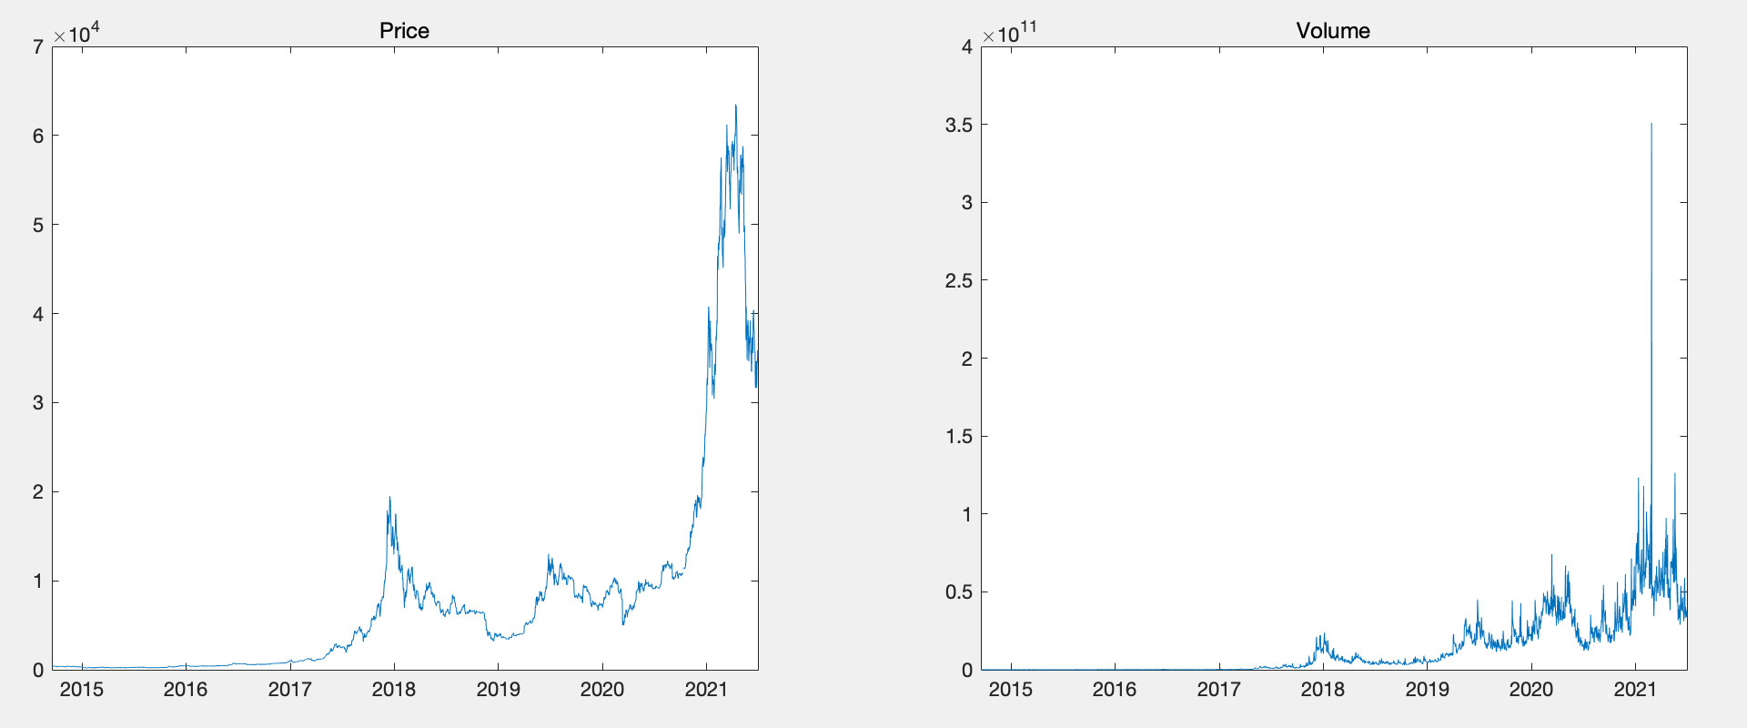3**. Data**

Fig 1. Price and volume values of Bitcoin from Sept. 17, 2014 to Jun 30, 2021.

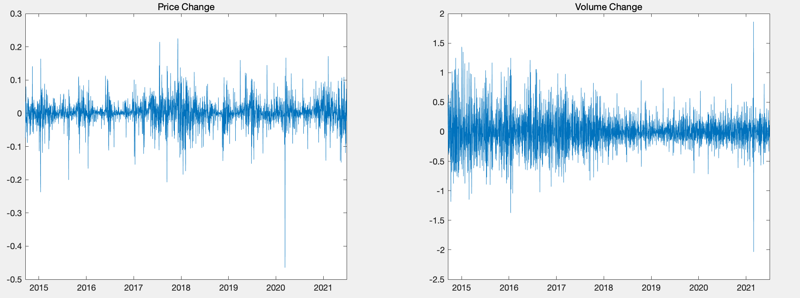

Fig 2. Price changes and volume changes of Bitcoin from Sept. 17, 2014 to Jun 30, 2021.

Table 1. Summary statistics

|  |  |  |  |  |  |  |  |  |
| --- | --- | --- | --- | --- | --- | --- | --- | --- |
|  | Mean | Max. | Min. | Std. Dev. | Skewness | Kurtosis | Jarque-Bera | Prob. |
| Bitcoin | 0.0017 | 0.2251 | -0.4647 | 0.0397 | -0.8261 | 14.5678 |  | 0.001 |
| Volume | 0.0030 | 1.8624 | -2.0340 | 0.3057 | 0.3169 | 6.2633 |  | 1 |

**4. Results**

4.1 Cross-Correlation test

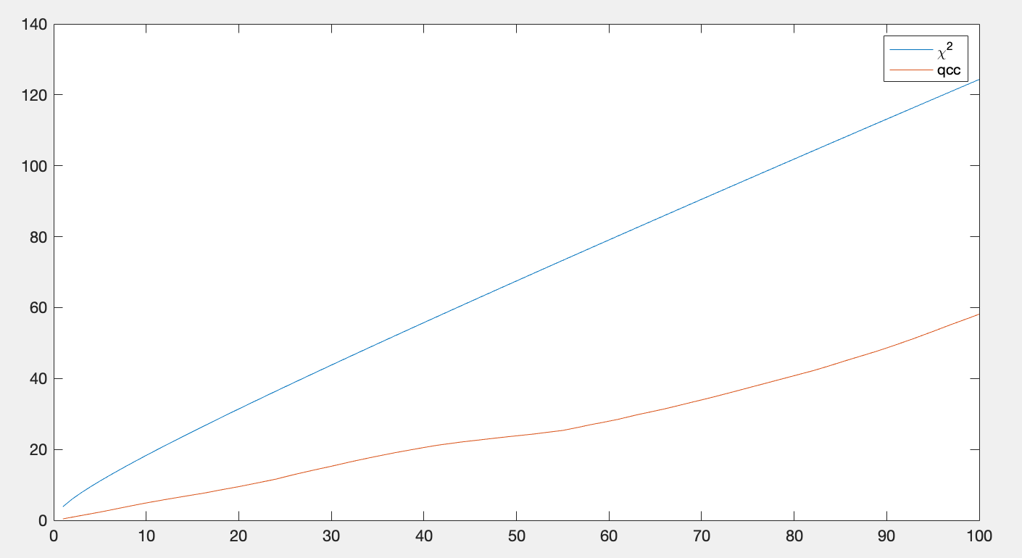

Fig 3. Cross-correlation statistics for price changes and volume changes of Bitcoin

When the correlation test is in good agreement with the χ2(m) distribution, there is no correlation. It is clear here that the Q statistic QCC(m) shows a value below the critical values of χ2(m).

4.2 Market efficiency and liquidity

Table 2. Return characteristics of Bitcoin sorted by liquidity

Sort by liquidity Return characteristics

|  |  |  |  |  |  |  |
| --- | --- | --- | --- | --- | --- | --- |
|  | Group | Amihud | Mean | Std. Dev | Skewness | Kurosis |
| High liquidity | 1 |  | 0.3138 | 0.0396 | -0.4218 | 10.4755 |
|  | 2 |  | -0.2896 | 0.0400 | -0.2309 | 5.9135 |
|  | 3 |  | 1.5723 | 0.0471 | -0.2561 | 6.2614 |
|  | 4 |  | 0.6172 | 0.0280 | -0.7348 | 10.5068 |
| Low liquidity | 5 |  | 0.1756 | 0.0329 | -1.2945 | 13.0378 |

Table 3. Market efficiency and the Hurst coefficient for Bitcoin sorted by liquidity

|  |  |  |  |  |  |  |
| --- | --- | --- | --- | --- | --- | --- |
| Sort by liquidity |  |  | Statistics for each estimate |  |  | Hurst |
|  | Group | Amihud | Ljung-Box | Bartel | AVR |  |
| High liquidity | 1 |  | 21.7054 | 0.0744 | -4.1880 | 0.5437 |
|  | 2 |  | 24.4880 | 0.2339 | -5.9268 | 0.5777 |
|  | 3 |  | 16.3106 | -0.7151 | -5.0464 | 0.5383 |
|  | 4 |  | 29.8168 | 0.9698 | -4.0701 | 0.5485 |
| Low liquidity | 5 |  | 30.3040 | 1.1725 | -3.3731 | 0.5315 |

Using the Amihud’s illiquidity indicator, Bitcoin's liquidity over the past 252 days was ranked from highest to lowest into five groups. By ranking the high and low levels of liquidity, we observe whether increasing or decreasing liquidity affects the predictability of returns.